CSE 2320 Notes 7: Dynamic Programming

(Last updated 11/7/26 10:58 PM)

CLRS 15.1-15.4

Dynamic Programming Approach

1. Describe problem input.

2. Determine cost function and base case.

3. Determine general case for cost function. THE HARD PART!!!

4. Appropriate ordering for enumerating subproblems.

a. Simple bottom-up approach - from small problems towards the entire big problem.

b. Top-down approach with “memoization” - to attack large problems.

5. Backtrace for solution. Most of the effort in dynamic programming is ignored at the end.

a. Predecessor/back pointers to get to the subproblems whose results are in the solution.

b. Top-down recomputation of cost function (to reach the same subproblems as 5.a)

(Providing all solutions is an extra cost feature . . .)

7.A. A Small Example – Shuttle-to-Airport

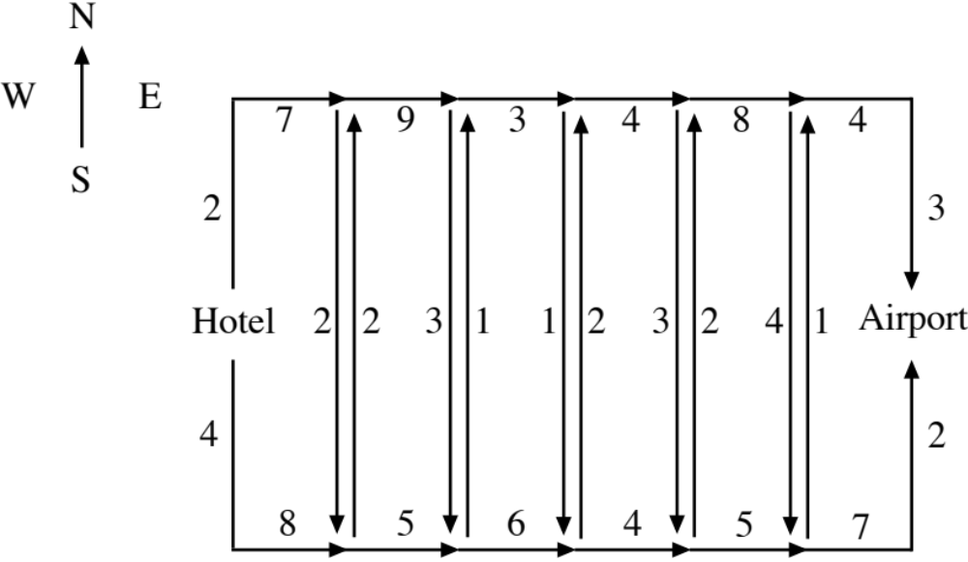

How many different paths (by brute force)?

Observation: To find optimal route, need optimal route to each street corner.

(Could also use Dijkstra’s algorithm, Notes 16, which is more general, but slower.)

1. Describe problem input.

Four arrays of paths, each with n values

Upper Direct = UD = ud₁ ud₂ . . . ud_{n} = 9 (2 + 7), 9, 3, 4, 8, 7 (4 + 3)

Lower Direct = LD = ld₁ ld₂ . . . ld_{n} = 12 (4 + 8), 5, 6, 4, 5, 9 (7 + 2)

Upper-to-Lower = UL = ul₁ ul₂ . . . ul_{n} = 2, 3, 1, 3, 4, ∞

Lower-to-Upper = LU = lu₁ lu₂ . . . lu_{n} = 2, 1, 2, 2, 1, ∞

2. Determine cost function and base case.

U(i) = Cost to reach upper corner i

L(i) = Cost to reach lower corner i

U(0) = 0

L(0) = 0

3. Determine general case.

U(i) = min { U(i - 1) + ud_{i}, L(i - 1) + ld_{i} + lu_{i} }

L(i) = min { L(i - 1) + ld_{i}, U(i - 1) + ud_{i} + ul_{i} }

4. Appropriate ordering of subproblems.

U(i) and L(i) cannot be computed without U(i - 1) and L(i - 1)

5. Backtrace for solution – either

a. ( http://ranger.uta.edu/~weems/NOTES2320/shuttle1.c ) explicitly save indication of which of the two cases was used (continue - c, switch - s), or

b. ( http://ranger.uta.edu/~weems/NOTES2320/shuttle2.c ) recheck during backtrace for which case was used.

0 1 2 3 4 5 6

U 0 9 (c) 17 (s) 20 (c) 24 (c) 31 (s) 38 (c)

L 0 11 (s) 16 (c) 21 (s) 25 (c) 30 (c) 39 (c)

Dynamic programming is:

1. Exhaustive search without brute force.

2. Optimal solution to big problem from optimal solutions to subproblems.

7.B. Weighted Interval Scheduling

Input: A set of n intervals numbered 1 through n with each interval i having start time , finish time 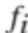, and positive weight ,

Output: A set of non-overlapping intervals to maximize the sum of their weights. (Two intervals i and j overlap if either 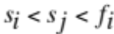 or 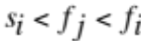.)

Brute-force solution: Enumerate the powerset of the input intervals, discard those cases with overlapping intervals, and compute the sum of the weights for each. ( http://ranger.uta.edu/~weems/NOTES2320/wis.power.c )

1. Describe problem input.

Assume the n intervals are in ascending finish time order, i.e. 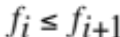.

Let 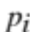 be the rightmost preceding interval for interval i, i.e. the largest value 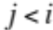 such that intervals i and j do not overlap. If no such interval j exists, 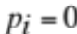. (These values may be computed in 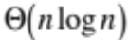 time using binSearchLast() from Notes 1. See http://ranger.uta.edu/~weems/NOTES2320/wis.bs.c )

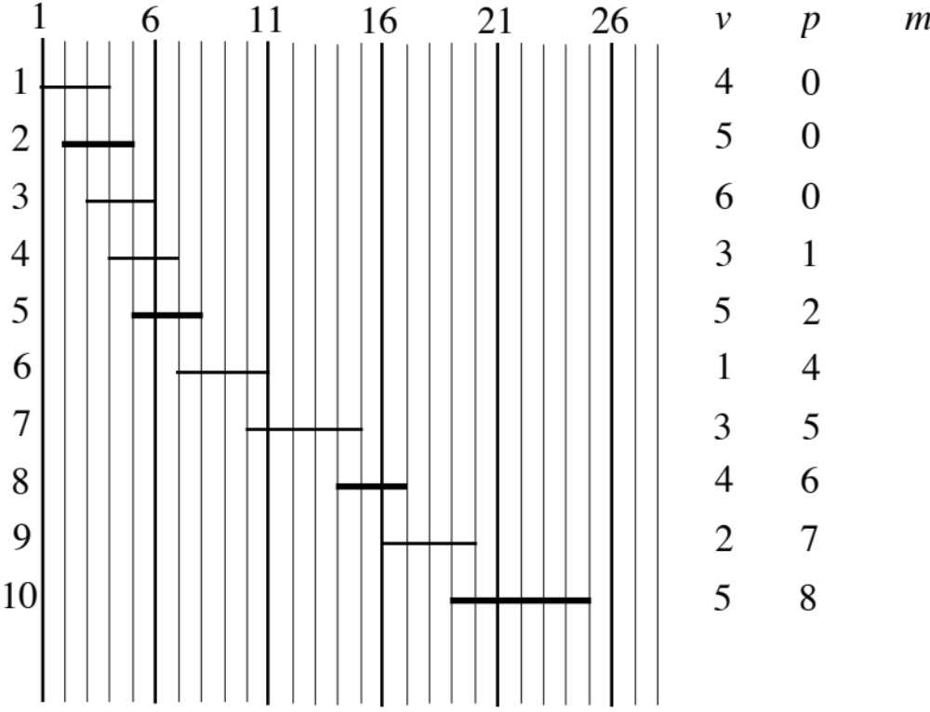

2. Determine cost function and base case.

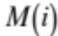 = Cost for optimal non-overlapping subset for the first i input intervals.

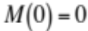

3. Determine general case.

For , the main issue is: Does the optimal subset include interval i?

If yes: optimal subset cannot include any overlapping intervals, so 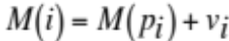.

If no: optimal subset is the same as for 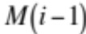, so 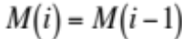.

This observation tells us to compute cost both ways and keep the maximum.

4. Appropriate ordering of subproblems. Simply compute in ascending i order.

5. Backtrace for solution (with recomputation). This is the subset of intervals for 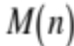.

i=n;

while (i>0)

if (v[i]+M[p[i]]>=M[i-1])

{

// Interval i is in solution

i=p[i];

}

else

i--;

7.C. Optimal Matrix Multiplication Ordering (very simplified version of query optimization)

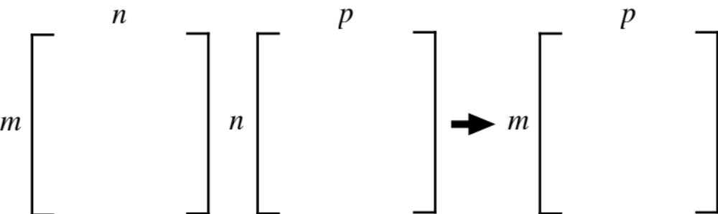

Only one strategy for multiplying two matrices – requires mnp scalar multiplications
(and m(n - 1)p additions).

There are two strategies for multiplying three matrices:

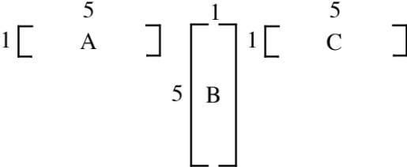
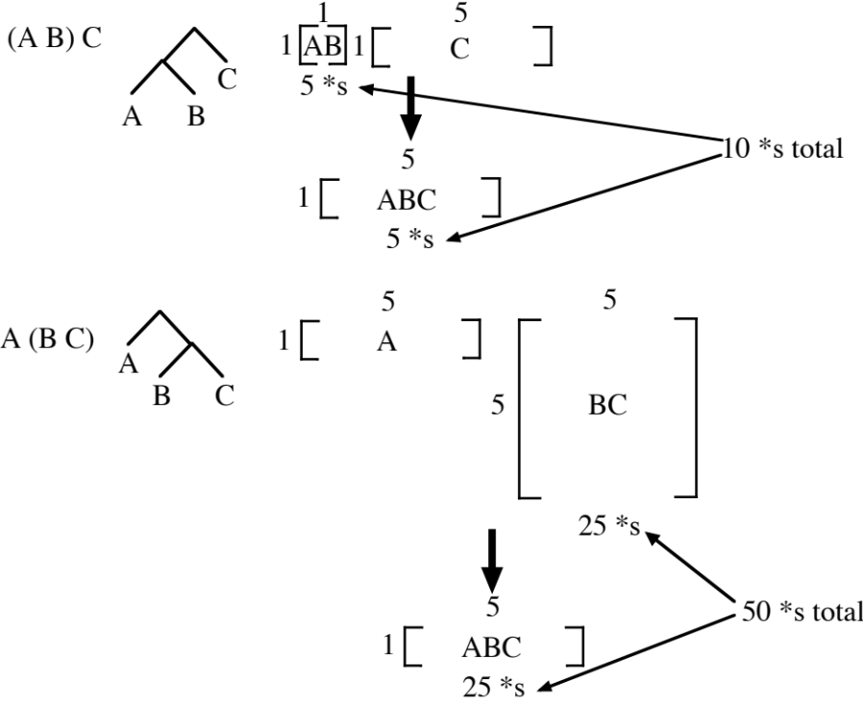

Aside: Ways to parenthesize n matrices? (Catalan numbers)

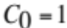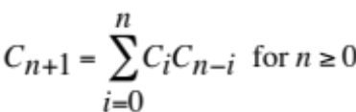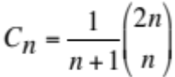

( http://en.wikipedia.org/wiki/Catalan_number )

Observation: Final tree cannot be optimal if any subtree is not.

1. Describe problem input.

n matrices ⇒ n + 1 sizes

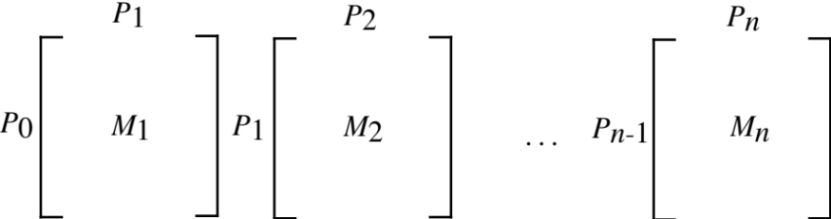
2. Determine cost function and base case.

C(i, j) = Cost for optimally multiplying M_{i} . . . M_{j}

C(i, i) = 0

3. Determine general case.

Consider a specific case C(5, 9). The optimal way to multiply M₅ . . . M₉ could be any of the following:

C(5, 5) + C(6, 9) + P₄P₅P₉

C(5, 6) + C(7, 9) + P₄P₆P₉

C(5, 7) + C(8, 9) + P₄P₇P₉

C(5, 8) + C(9, 9) + P₄P₈P₉

Compute all four and keep the smallest one.

Abstractly: Trying to find C(i, j)

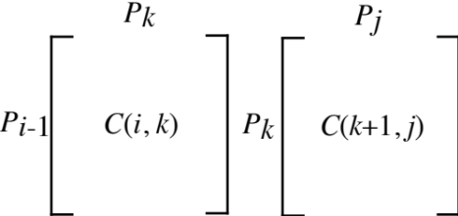

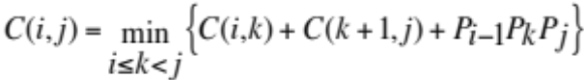

4. Appropriate ordering of subproblems.

Since smaller subproblems are needed to solve larger problems, run value for j – i for C(i, j) from 0 to n – 1. Suppose :

_0 1 2 3 4
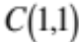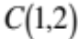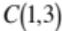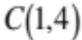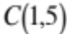
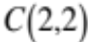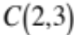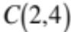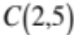
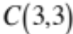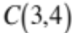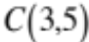
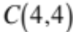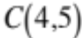
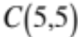

5. Backtrace for solution – explicitly save the k value that gave each C(i, j).

http://ranger.uta.edu/~weems/NOTES2320/optMM.c

// Optimal matrix multiplication order using dynamic programming

#include <stdio.h>

int p[20];
int n;
int c[20][20];
int trace[20][20];

void tree(int left,int right,int indent)
{
int i;

if (left==right)
{
for (i=0;i<indent;i++)
printf(" ");
printf("%d\n",left);
return;
}
tree(trace[left][right]+1,right,indent+1);
for (i=0;i<indent;i++)
printf(" ");
printf("%d %d\n",left,right);
tree(left,trace[left][right],indent+1);
}

int main()
{
int i,j,k;
int work;

scanf("%d",&n);

for (i=0;i<=n;i++)
scanf("%d",&p[i]);

for (i=1;i<=n;i++)
c[i][i]=trace[i][i]=0;

for (i=1;i<n;i++)
for (j=1;j<=n-i;j++)
{
printf("Compute c[%d][%d]\n",j,j+i);
c[j][j+i]=999999;
for (k=j;k<j+i;k++)
{
work=c[j][k]+c[k+1][j+i]+p[j-1]*p[k]*p[j+i];
printf(" k=%d gives cost %3d=c[%d][%d]+c[%d][%d]+p[%d]*p[%d]*p[%d]\n",
k,work,j,k,k+1,j+i,j-1,k,j+i);
if (c[j][j+i]>work)
{
c[j][j+i]=work;
trace[j][j+i]=k;
}
}
printf(" c[%d][%d]==%d,trace[%d][%d]==%d\n",j,j+i,
c[j][j+i],j,j+i,trace[j][j+i]);
}

printf(" ");
for (i=1;i<=n;i++)
printf(" %3d ",i);
printf("\n");
for (i=1;i<=n;i++)
{
printf("%2d ",i);
for (j=1;j<=n;j++)
if (i>j)
printf(" ------- ");
else
printf(" %3d %3d ",c[i][j],trace[i][j]);
printf("\n");

printf("\n");
}

tree(1,n,0);
}
It is straightforward to use integration to determine that the k loop body executes about 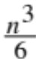 times.

4
2 4 3 5 2
Compute c[1][2]
k=1 gives cost 24=c[1][1]+c[2][2]+p[0]*p[1]*p[2]
c[1][2]==24,trace[1][2]==1
Compute c[2][3]
k=2 gives cost 60=c[2][2]+c[3][3]+p[1]*p[2]*p[3]
c[2][3]==60,trace[2][3]==2
Compute c[3][4]
k=3 gives cost 30=c[3][3]+c[4][4]+p[2]*p[3]*p[4]
c[3][4]==30,trace[3][4]==3
Compute c[1][3]
k=1 gives cost 100=c[1][1]+c[2][3]+p[0]*p[1]*p[3]
k=2 gives cost 54=c[1][2]+c[3][3]+p[0]*p[2]*p[3]
c[1][3]==54,trace[1][3]==2
Compute c[2][4]
k=2 gives cost 54=c[2][2]+c[3][4]+p[1]*p[2]*p[4]
k=3 gives cost 100=c[2][3]+c[4][4]+p[1]*p[3]*p[4]
c[2][4]==54,trace[2][4]==2
Compute c[1][4]
k=1 gives cost 70=c[1][1]+c[2][4]+p[0]*p[1]*p[4]
k=2 gives cost 66=c[1][2]+c[3][4]+p[0]*p[2]*p[4]
k=3 gives cost 74=c[1][3]+c[4][4]+p[0]*p[3]*p[4]
c[1][4]==66,trace[1][4]==2
1 2 3 4
1 0 0 24 1 54 2 66 2

2 ------- 0 0 60 2 54 2

3 ------- ------- 0 0 30 3

4 ------- ------- ------- 0 0

4
3 4
3
1 4
2
1 2
1

7
1 7 9 5 1 5 10 3
Compute c[1][2]
k=1 gives cost 63=c[1][1]+c[2][2]+p[0]*p[1]*p[2]
c[1][2]==63,trace[1][2]==1
Compute c[2][3]
k=2 gives cost 315=c[2][2]+c[3][3]+p[1]*p[2]*p[3]
c[2][3]==315,trace[2][3]==2
Compute c[3][4]
k=3 gives cost 45=c[3][3]+c[4][4]+p[2]*p[3]*p[4]
c[3][4]==45,trace[3][4]==3
Compute c[4][5]
k=4 gives cost 25=c[4][4]+c[5][5]+p[3]*p[4]*p[5]
c[4][5]==25,trace[4][5]==4
Compute c[5][6]
k=5 gives cost 50=c[5][5]+c[6][6]+p[4]*p[5]*p[6]
c[5][6]==50,trace[5][6]==5
Compute c[6][7]
k=6 gives cost 150=c[6][6]+c[7][7]+p[5]*p[6]*p[7]
c[6][7]==150,trace[6][7]==6
Compute c[1][3]
k=1 gives cost 350=c[1][1]+c[2][3]+p[0]*p[1]*p[3]
k=2 gives cost 108=c[1][2]+c[3][3]+p[0]*p[2]*p[3]
c[1][3]==108,trace[1][3]==2
Compute c[2][4]
k=2 gives cost 108=c[2][2]+c[3][4]+p[1]*p[2]*p[4]
k=3 gives cost 350=c[2][3]+c[4][4]+p[1]*p[3]*p[4]
c[2][4]==108,trace[2][4]==2
Compute c[3][5]
k=3 gives cost 250=c[3][3]+c[4][5]+p[2]*p[3]*p[5]
k=4 gives cost 90=c[3][4]+c[5][5]+p[2]*p[4]*p[5]
c[3][5]==90,trace[3][5]==4
Compute c[4][6]
k=4 gives cost 100=c[4][4]+c[5][6]+p[3]*p[4]*p[6]
k=5 gives cost 275=c[4][5]+c[6][6]+p[3]*p[5]*p[6]
c[4][6]==100,trace[4][6]==4
Compute c[5][7]
k=5 gives cost 165=c[5][5]+c[6][7]+p[4]*p[5]*p[7]
k=6 gives cost 80=c[5][6]+c[7][7]+p[4]*p[6]*p[7]
c[5][7]==80,trace[5][7]==6
Compute c[1][4]
k=1 gives cost 115=c[1][1]+c[2][4]+p[0]*p[1]*p[4]
k=2 gives cost 117=c[1][2]+c[3][4]+p[0]*p[2]*p[4]
k=3 gives cost 113=c[1][3]+c[4][4]+p[0]*p[3]*p[4]
c[1][4]==113,trace[1][4]==3
Compute c[2][5]
k=2 gives cost 405=c[2][2]+c[3][5]+p[1]*p[2]*p[5]
k=3 gives cost 515=c[2][3]+c[4][5]+p[1]*p[3]*p[5]
k=4 gives cost 143=c[2][4]+c[5][5]+p[1]*p[4]*p[5]
c[2][5]==143,trace[2][5]==4
Compute c[3][6]
k=3 gives cost 550=c[3][3]+c[4][6]+p[2]*p[3]*p[6]
k=4 gives cost 185=c[3][4]+c[5][6]+p[2]*p[4]*p[6]
k=5 gives cost 540=c[3][5]+c[6][6]+p[2]*p[5]*p[6]
c[3][6]==185,trace[3][6]==4
Compute c[4][7]
k=4 gives cost 95=c[4][4]+c[5][7]+p[3]*p[4]*p[7]
k=5 gives cost 250=c[4][5]+c[6][7]+p[3]*p[5]*p[7]
k=6 gives cost 250=c[4][6]+c[7][7]+p[3]*p[6]*p[7]
c[4][7]==95,trace[4][7]==4
Compute c[1][5]
k=1 gives cost 178=c[1][1]+c[2][5]+p[0]*p[1]*p[5]
k=2 gives cost 198=c[1][2]+c[3][5]+p[0]*p[2]*p[5]
k=3 gives cost 158=c[1][3]+c[4][5]+p[0]*p[3]*p[5]
k=4 gives cost 118=c[1][4]+c[5][5]+p[0]*p[4]*p[5]
c[1][5]==118,trace[1][5]==4
Compute c[2][6]
k=2 gives cost 815=c[2][2]+c[3][6]+p[1]*p[2]*p[6]
k=3 gives cost 765=c[2][3]+c[4][6]+p[1]*p[3]*p[6]
k=4 gives cost 228=c[2][4]+c[5][6]+p[1]*p[4]*p[6]
k=5 gives cost 493=c[2][5]+c[6][6]+p[1]*p[5]*p[6]
c[2][6]==228,trace[2][6]==4
Compute c[3][7]
k=3 gives cost 230=c[3][3]+c[4][7]+p[2]*p[3]*p[7]
k=4 gives cost 152=c[3][4]+c[5][7]+p[2]*p[4]*p[7]
k=5 gives cost 375=c[3][5]+c[6][7]+p[2]*p[5]*p[7]
k=6 gives cost 455=c[3][6]+c[7][7]+p[2]*p[6]*p[7]
c[3][7]==152,trace[3][7]==4
Compute c[1][6]
k=1 gives cost 298=c[1][1]+c[2][6]+p[0]*p[1]*p[6]
k=2 gives cost 338=c[1][2]+c[3][6]+p[0]*p[2]*p[6]
k=3 gives cost 258=c[1][3]+c[4][6]+p[0]*p[3]*p[6]
k=4 gives cost 173=c[1][4]+c[5][6]+p[0]*p[4]*p[6]
k=5 gives cost 168=c[1][5]+c[6][6]+p[0]*p[5]*p[6]
c[1][6]==168,trace[1][6]==5
Compute c[2][7]
k=2 gives cost 341=c[2][2]+c[3][7]+p[1]*p[2]*p[7]
k=3 gives cost 515=c[2][3]+c[4][7]+p[1]*p[3]*p[7]
k=4 gives cost 209=c[2][4]+c[5][7]+p[1]*p[4]*p[7]
k=5 gives cost 398=c[2][5]+c[6][7]+p[1]*p[5]*p[7]
k=6 gives cost 438=c[2][6]+c[7][7]+p[1]*p[6]*p[7]
c[2][7]==209,trace[2][7]==4
Compute c[1][7]
k=1 gives cost 230=c[1][1]+c[2][7]+p[0]*p[1]*p[7]
k=2 gives cost 242=c[1][2]+c[3][7]+p[0]*p[2]*p[7]
k=3 gives cost 218=c[1][3]+c[4][7]+p[0]*p[3]*p[7]
k=4 gives cost 196=c[1][4]+c[5][7]+p[0]*p[4]*p[7]
k=5 gives cost 283=c[1][5]+c[6][7]+p[0]*p[5]*p[7]
k=6 gives cost 198=c[1][6]+c[7][7]+p[0]*p[6]*p[7]
c[1][7]==196,trace[1][7]==4

1 2 3 4 5 6 7
1 0 0 63 1 108 2 113 3 118 4 168 5 196 4

2 ------- 0 0 315 2 108 2 143 4 228 4 209 4

3 ------- ------- 0 0 45 3 90 4 185 4 152 4

4 ------- ------- ------- 0 0 25 4 100 4 95 4

5 ------- ------- ------- ------- 0 0 50 5 80 6

6 ------- ------- ------- ------- ------- 0 0 150 6

7 ------- ------- ------- ------- ------- ------- 0 0

7
5 7
6
5 6
5
1 7
4
1 4
3
1 3
2
1 2
1

(Aside) Like optimal matrix multiplication, the order-preserving Huffman code problem mentioned in Notes 06 requires a solution with the leaves in alphabetic order. The cost function is based on minimizing the expected bits/symbol under this restriction:

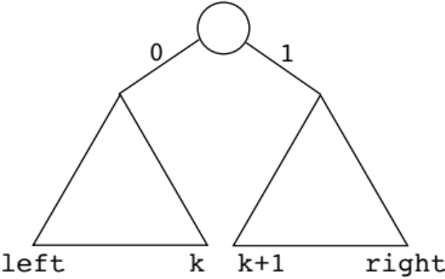

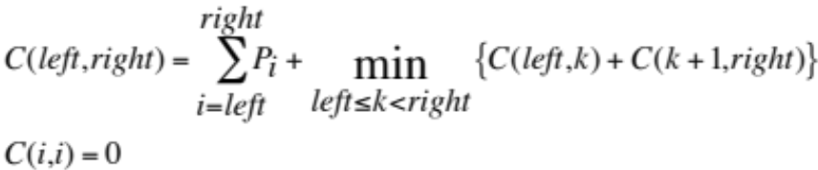

7.D. Longest Common Subsequence (not substring, http://ranger.uta.edu/~weems/NOTES2320/LCS.c )

Has important applications in genetics research.

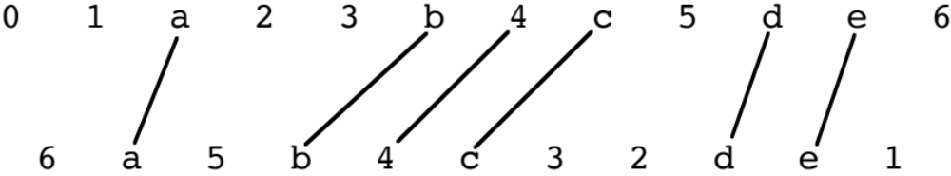

1. Describe problem input.

Two sequences:

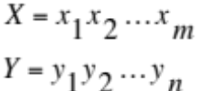

2. Determine cost function and base case.

C(i, j) = length of LCS for 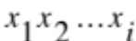 and 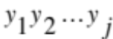

C(i, j) = 0 if i = 0 or j = 0

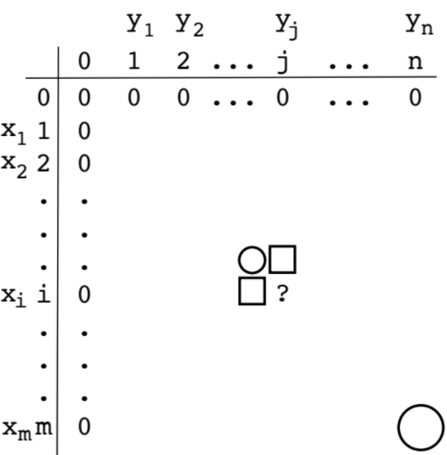

3. Determine general case.

Suppose 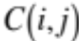 has

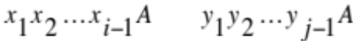

Since 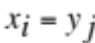, 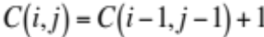

Now suppose 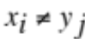:

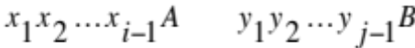

But ‘B’ may appear in 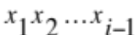 or ‘A’ may appear in 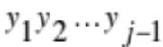:

4. Appropriate ordering of subproblems.

Before computing , must have 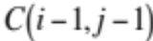, 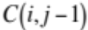, and 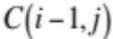 available.

Use (m + 1) × (n + 1) matrix to store C values.

5. Backtrace for solution – either explictly save indication of which of the three cases was used or recheck C values.

Takes Θ(mn) time. (Aside: Can be done using 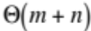 space.)

Example:

ababab
aabbaa

LCS is abaa, length==4
a a b b a a

0 0 0 0 0 0 0
a 0 1 1 1 1 1 1
b 0 1 1 2 2 2 2
a 0 1 2 2 2 3 3
b 0 1 2 3 3 3 3
a 0 1 2 3 3 4 4
b 0 1 2 3 4 4 4

7.E. Longest Increasing Subsequence

Monotone: For an input sequence 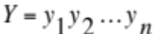, find a longest subsequence in increasing (≤) order.

Strict: For an input sequence , find a longest subsequence in strictly increasing (<) order.

Both versions may be solved inefficiently by reduction to LCS:

Monotone: 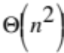 worst-case time by taking LCS of sequence and its elements sorted in ascending order.

1122346778
6178213472
LCS is 11347, length==5
6 1 7 8 2 1 3 4 7 2
0 0 0 0 0 0 0 0 0 0 0
1 0 0 1 1 1 1 1 1 1 1 1
1 0 0 1 1 1 1 2 2 2 2 2
2 0 0 1 1 1 2 2 2 2 2 3
2 0 0 1 1 1 2 2 2 2 2 3
3 0 0 1 1 1 2 2 3 3 3 3
4 0 0 1 1 1 2 2 3 4 4 4
6 0 1 1 1 1 2 2 3 4 4 4
7 0 1 1 2 2 2 2 3 4 5 5
7 0 1 1 2 2 2 2 3 4 5 5
8 0 1 1 2 3 3 3 3 4 5 5

Strict: 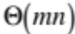 worst-case time, where m is the number of unique integers occuring in input.

1234678
6178213472
LCS is 12347, length==5
6 1 7 8 2 1 3 4 7 2
0 0 0 0 0 0 0 0 0 0 0
1 0 0 1 1 1 1 1 1 1 1 1
2 0 0 1 1 1 2 2 2 2 2 2
3 0 0 1 1 1 2 2 3 3 3 3
4 0 0 1 1 1 2 2 3 4 4 4
6 0 1 1 1 1 2 2 3 4 4 4
7 0 1 1 2 2 2 2 3 4 5 5
8 0 1 1 2 3 3 3 3 4 5 5

Both versions may be solved in worst-case time, using an appropriate DP cost function and n binary searches.

Monotone ( http://ranger.uta.edu/~weems/NOTES2320/LIS.c ):

1. Describe problem input.

2. Determine cost function and base case.

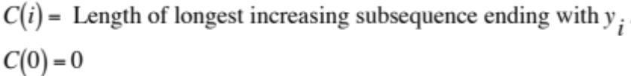

3. Determine general case for cost function.

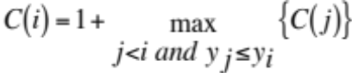 (The j that gives 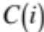 may be saved for backtrace.)

4. Appropriate ordering of subproblems - iterate over the prefix length, saving C and j for each i.

i 1 2 3 4 5 6 7 8 9 10

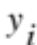 60 10 70 80 20 10 30 40 70 20

C 1 1 2 3 2 2 3 4 5 3

j 0 0 2 3 2 2 6 7 8 6

5. Backtrace for solution.

Find the rightmost occurence of the maximum C value. The corresponding y will be minimized.

Appears to take , but binSearchLast() from Notes 1 may be used to find each C and j pair in 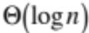 time to give overall:

// Initialize table for binary search for DP
bsTabC[0]=(-999999); // Must be smaller than all input values.
bsTabI[0]=0; // Index of predecessor (0=grounded)
for (i=1;i<=n;i++)
bsTabC[i]=999999; // Must be larger than all input values.

C[0]=0; // DP base case
j[0]=0;

for (i=1;i<=n;i++)
{
// Find IS that y[i] could be appended to.
// See CSE 2320 Notes 01 for binSearchLast()
k=binSearchLast(bsTabC,n+1,y[i]);
C[i]=k+1; // Save length of LIS for y[i]
j[i]=bsTabI[k]; // Predecessor of y[i]
bsTabC[k+1]=y[i]; // Decrease value for this length IS
bsTabI[k+1]=i;
}

i 1 2 3 4 5 6 7 8 9 10

60 10 70 80 20 10 30 40 70 20

C

j

1

2

3

4

5

Strict ( http://ranger.uta.edu/~weems/NOTES2320/LSIS.c ): Similar to monotone with the following exceptions:

2. Determine cost function and base case.

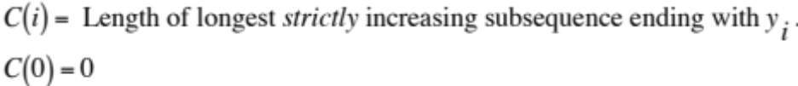

3. Determine general case for cost function.

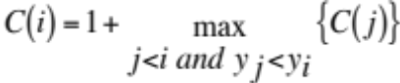 (The j that gives must be saved to allow backtrace.)

Finally, any that is found by binSearchLast() will be ignored.
for (i=1;i<=n;i++)
{
// Find SIS that y[i] could be appended to.
// See CSE 2320 Notes 01 for binSearchLast()
k=binSearchLast(bsTabC,n+1,y[i]);
// y[i] only matters if it is not already in table.
if (bsTabC[k]<y[i]) {
C[i]=k+1; // Save length of LIS for y[i]
j[i]=bsTabI[k]; // Predecessor of y[i]
bsTabC[k+1]=y[i]; // Decrease value for this length IS
bsTabI[k+1]=i;
}
else
{
C[i]=(-1); // Mark as ignored
j[i]=(-1);
}
}

i 1 2 3 4 5 6 7 8 9 10

60 10 70 80 20 10 30 40 70 20

C

j

1

2

3

4

5

Suppose a value k appears for p entries in the cost function table (C) for an instance of the longest monotonically increasing subsequence problem. Going left-to-right across the corresponding input sequence values (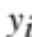), which statement is true?

(Stated formally: For 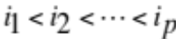, suppose 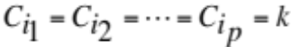. Which statement is true regarding 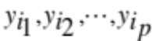?)

_____ A. They are monotonically decreasing
B. They are strictly increasing
C. They are monotonically increasing
D. They are strictly decreasing

7.F. Subset Sum ( http://ranger.uta.edu/~weems/NOTES2320/subsetSum.c )

Given a “set” of n positive integer values, find a subset whose sum adds to a value m.

Optimization?

Enumerating subsets (combinations) would take exponential time.

1. Describe problem input. Array 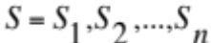 and m.

2. Determine cost function and base case.

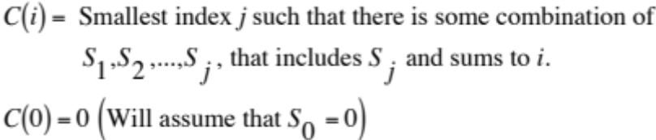

3. Determine general case for cost function.

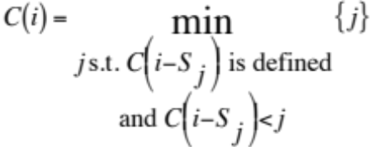

4. Appropriate ordering of subproblems:

a. Iterate over i looking backwards (like the cost function) to previous “finalized” solutions.

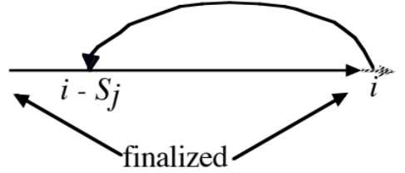

b. (Aside, Dijkstra’s algorithm-like) Iterate over finalized to compute 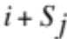 for each 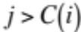 and attempt update forward. After updates, 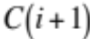 has final value.

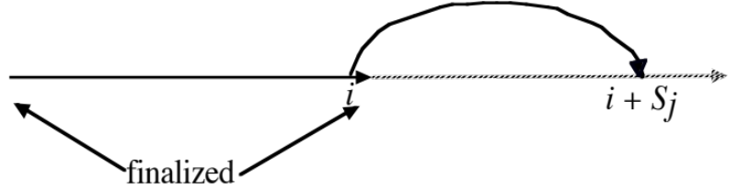

c. (Aside) Maintain ordered list of finalized solutions from using 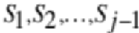 and generate new ordered list that also uses 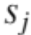 to reach some new values.

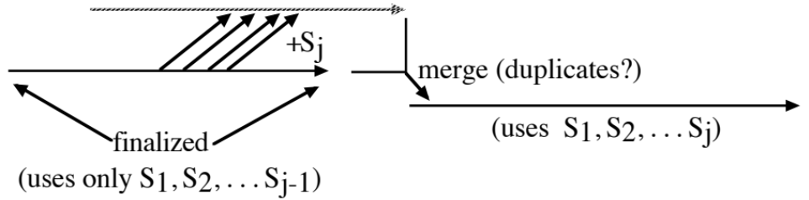

5. Backtrace for solution - if 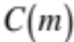 is defined, then backtrace using C values to subtract out each value in subset. (Indices will appear in strictly decreasing order during backtrace.)

// Initialize table for DP
C[0]=0; // DP base case
// For each potential sum, determine the smallest index such
// that its input value is in a subset to achieve that sum.
for (potentialSum=1; potentialSum<=m; potentialSum ++)
{
for (j=1;j<=n;j++)
{
leftover=potentialSum-S[j]; // To be achieved with other values
if (leftover>=0 && // Possible to have a solution
C[leftover]<j) // Indices are included in
break; // ascending order.
}
C[potentialSum]=j;
}

if (C[m]==n+1)
printf("No solution\n");
else
{
printf("Solution\n");
printf(" i S\n");
printf("-------\n");
for (i=m;i>0;i-=S[C[i]])
printf("%3d %3d\n",C[i],S[C[i]]);
}

Example: m = 12, n = 4

i 0 1 2 3 4

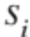 0 3 6 7 9 [The values do not require ordering.]

i 0 1 2 3 4 5 6 7 8 9 10 11 12

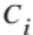

Time is . Space is 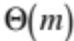. [What happens if m and each are multiplied by the same constant?]

Another subset sum example ( http://ranger.uta.edu/~weems/NOTES2320/subsetSum.c )

5 18
2 3 5 7 11
i S
-------
0 0
1 2
2 3
3 5
4 7
5 11
i C
-------
0 0
1 6
2 1
3 2
4 6
5 2
6 6
7 3
8 3
9 4
10 3
11 5
12 4
13 5
14 4
15 4
16 5
17 4
18 5
Solution
i S
-------
5 11
3 5

1 2

7.G. 0/1 (Indivisible, Unbounded) Knapsack - Optimal Solution

( http://ranger.uta.edu/~weems/NOTES2320/knapsackTypeRS.c )

CLRS 15.1 calls this the rod-cutting problem.

n item types, each with an integer size and value (CLRS - type = rod, size = length, value = price).

Unlike conventional version (Notes 6), unlimited supply of each type.
m, the integer capacity of the knapsack (length of the longer rod to be cut)

Goal: Select a combination from the unlimited supply of items that

1) maximizes the sum of the values, and
2) the sum of the sizes does not exceed m.

1. Describe problem input. Array size of n weights, array val of n values, and m.

2. Determine cost function and base case.

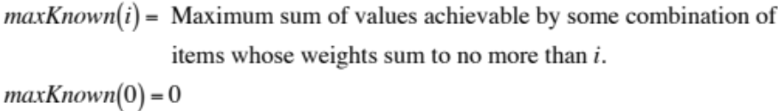

3. Determine general case for cost function.

4. Appropriate ordering of subproblems - since goal is to compute 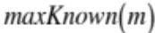, extra cases could be computed. Use array of 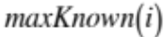 values along with unknown indicator to implement memoization (top-down).

// From Sedgewick
int knap(int M,int level)
{ int i, space, max, maxi = 0, t;
for (i=0;i<level;i++)
printf(".");
if (maxKnown[M] != unknown)
{
printf("Reusing knap(%d)=%d\n",M,maxKnown[M]);
return maxKnown[M];
}
printf("Start knap(%d)\n",M);
for (i = 0, max = 0; i < N; i++)
if ((space = M-items[i].size) >= 0)
if ((t = knap(space,level+1) + items[i].val) > max)
{ max = t; maxi = i; }
maxKnown[M] = max; itemKnown[M] = items[maxi];
for (i=0;i<level;i++)
printf(".");
printf("Finish knap(%d)\n",M);
return max; }

. . .

// Since knap() uses memoization, a bottom-up loop is not needed.

printf("Maximum for %d is %d\n",m,knap(m,0));

5. Backtrace for solution - backtrace using maxKnown and itemKnown.

Example: m=46

i 0 1 2 3

size 11 13 17 19

val 10 14 16 20

i 11 12 13 14 16 18 20 22 24 27 29 33 35 46

maxKnown 10 10 14 14 14 16 20 20 24 28 28 34 34 48

size 11 11 13 13 13 17 19 11 11 13 13 13 11 13

val 10 10 14 14 14 16 20 10 10 14 14 14 10 14

Time is . Space is .

Start knap(46)

.Start knap(35)

..Start knap(24)

...Start knap(13)

....Start knap(2)

....Finish knap(2)

....Start knap(0)

....Finish knap(0)

...Finish knap(13)

...Start knap(11)

....Reusing knap(0)=0

...Finish knap(11)

...Start knap(7)

...Finish knap(7)

...Start knap(5)

...Finish knap(5)

..Finish knap(24)

..Start knap(22)

...Reusing knap(11)=10

...Start knap(9)

...Finish knap(9)

...Reusing knap(5)=0

...Start knap(3)

...Finish knap(3)

..Finish knap(22)

..Start knap(18)

...Reusing knap(7)=0

...Reusing knap(5)=0

...Start knap(1)

...Finish knap(1)

..Finish knap(18)

..Start knap(16)

...Reusing knap(5)=0

...Reusing knap(3)=0

..Finish knap(16)

.Finish knap(35)

.Start knap(33)

..Reusing knap(22)=20

..Start knap(20)

...Reusing knap(9)=0

...Reusing knap(7)=0

...Reusing knap(3)=0

...Reusing knap(1)=0

..Finish knap(20)

..Reusing knap(16)=14

..Start knap(14)

...Reusing knap(3)=0

...Reusing knap(1)=0

..Finish knap(14)

.Finish knap(33)

.Start knap(29)

..Reusing knap(18)=16

..Reusing knap(16)=14

..Start knap(12)

...Reusing knap(1)=0

..Finish knap(12)

..Start knap(10)

..Finish knap(10)

.Finish knap(29)

.Start knap(27)

..Reusing knap(16)=14

..Reusing knap(14)=14

..Reusing knap(10)=0

..Start knap(8)

..Finish knap(8)

.Finish knap(27)

Finish knap(46)

Maximum for 46 is 48

i size val

------------

0 11 10

1 13 14

2 17 16

3 19 20

i max size val

----------------

11 10 11 10

12 10 11 10

13 14 13 14

14 14 13 14

16 14 13 14

18 16 17 16

20 20 19 20

22 20 11 10

24 24 11 10

27 28 13 14

29 28 13 14

33 34 13 14

35 34 11 10

46 48 13 14

Solution has value 48:

i size val

-------------

1 13 14

2 13 14

3 19 20

Unused capacity 1

